Unit-4

|  |  |
| --- | --- |
| **Unit – IV**  **Deep Learning Medical Image Segmentation** | **Contact Hours = 8 Hours**  **Flipped Classes Content = 2 Hours** |
| Introduction to Digital Image Segmentation, operators - filters for edge and line detection, simple segmentation algorithms, significance of Image Segmentation in Medical Image, classification of digital image segmentation algorithms, automatic image segmentation, Architecture of U-Net segmentation. | |
| **Topics for Flipped Classes:** Case study review on Biomedical Image Segmentation | |

**Introduction to Digital Image Segmentation**

Image segmentation is a commonly used technique in digital image processing and analysis to partition an image into multiple parts or regions, often based on the characteristics of the pixels in the image. Image segmentation could involve separating foreground from background, or clustering regions of pixels based on similarities in color or shape. For example, a common application of image segmentation in medical imaging is to detect and label pixels in an image or voxels of a 3D volume that represent a [tumor in a patient’s brain](https://in.mathworks.com/help/deeplearning/ug/segment-3d-brain-tumor-using-deep-learning.html) or other organs.

What is medical image segmentation?

Medical image segmentation, essentially the same as natural image segmentation, refers to the process of extracting the desired object (organ) from a medical image (2D or 3D), which can be done manually, semi-automatically or fully-automatically.

For example, a common application of image segmentation in medical imaging is to detect and label pixels in an image or voxels of a 3D volume that represent a tumor in a patient's brain or other organs

**Biomedical Image Segmentation**

What are the types of image segmentation?

**Image Segmentation Techniques**

* Threshold Based Segmentation.
* Edge Based Segmentation.
* Region-Based Segmentation.
* Clustering Based Segmentation.
* Artificial Neural Network Based Segmentation.

## **Why Image Segmentation Matters**

Several algorithms and techniques for image segmentation have been developed over the years using domain-specific knowledge to effectively solve segmentation problems in that specific application area.  These applications include medical imaging, automated driving, video surveillance, and machine vision.

### **Medical Imaging**

During medical diagnosis for cancer, pathologists stain body tissue with hematoxylin and eosin (H&E) to distinguish between tissue types. They then use an image segmentation technique called *clustering* to identify those tissue types in their images. [Clustering](https://in.mathworks.com/help/images/color-based-segmentation-using-k-means-clustering.html) is a method to separate groups of objects in a scene. The K-means clustering algorithm finds separations such that objects within each cluster are as close to each other as possible, and as far from other objects in other clusters as possible.

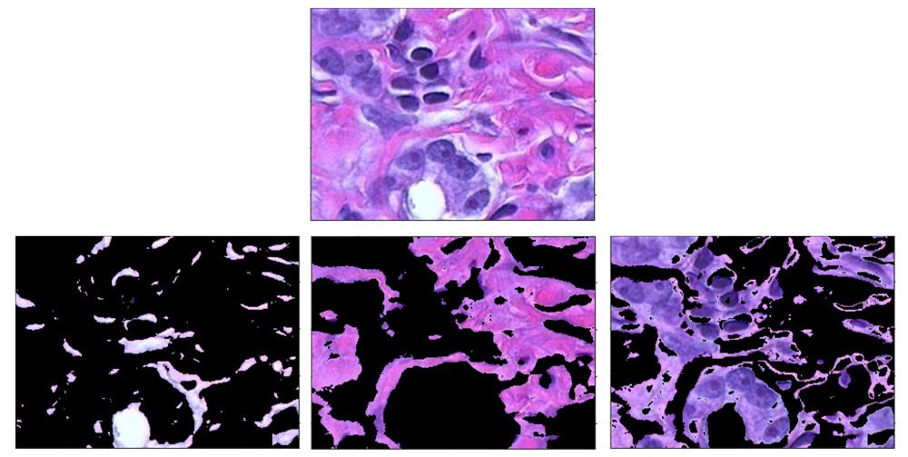

Using clustering to distinguish between tissue types (bottom) in an image of body tissue (top) stained with hematoxylin and eosin (H&E).

### **Deep Learning for Image Segmentation**

Using convolutional neural networks (CNNs), a deep learning technique called semantic segmentation lets you associate every pixel of an image with a class label. Applications for semantic segmentation include autonomous driving, industrial inspection, medical imaging, and satellite image analysis.

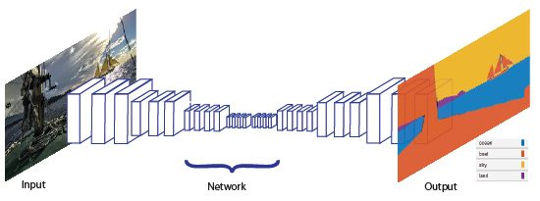

Schematic of semantic segmentation technique.

<https://www.google.com/search?client=firefox-b-d&q=biomedical++Image+Segmentation>

**Read this Document:**

# Computer Vision Tutorial: A Step-by-Step Introduction to Image Segmentation Techniques (Part 1)

# https://www.analyticsvidhya.com/blog/2019/04/introduction-image-segmentation-techniques-python/

<https://www.upgrad.com/blog/image-segmentation-techniques/>

**U net Segmenation:**

What is U-Net image segmentation?

[[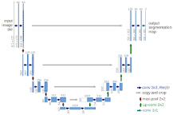](https://www.google.com/search?client=firefox-b-d&sxsrf=APq-WBtDvj6ynLHu0_K_x_heHH_5pi1ngg:1644911505490&q=What+is+U-Net+image+segmentation?&tbm=isch&source=iu&ictx=1&vet=1&fir=K-wr6kKnRJ4HPM%252CYFqzK8tFIj47CM%252C_&usg=AI4_-kR60uzdYR63F3dDDYNpTmpzngDs6Q&sa=X&ved=2ahUKEwi70-LvnIH2AhVgSWwGHSJOBAsQ9QF6BAhBEAE#imgrc=K-wr6kKnRJ4HPM)](https://www.google.com/search?client=firefox-b-d&sxsrf=APq-WBtDvj6ynLHu0_K_x_heHH_5pi1ngg:1644911505490&q=What+is+U-Net+image+segmentation?&tbm=isch&source=iu&ictx=1&vet=1&fir=K-wr6kKnRJ4HPM%252CYFqzK8tFIj47CM%252C_&usg=AI4_-kR60uzdYR63F3dDDYNpTmpzngDs6Q&sa=X&ved=2ahUKEwi70-LvnIH2AhVgSWwGHSJOBAsQ9QF6BAhBEAE" \l "imgrc=K-wr6kKnRJ4HPM)

The u-net is **convolutional network architecture for fast and precise segmentation of images**. ... U-net architecture (example for 32x32 pixels in the lowest resolution). Each blue box corresponds to a multi-channel feature map. The number of channels is denoted on top of the box.

[**https://towardsdatascience.com/understanding-semantic-segmentation-with-unet-6be4f42d4b47**](https://towardsdatascience.com/understanding-semantic-segmentation-with-unet-6be4f42d4b47)

[**https://arxiv.org/abs/1505.04597**](https://arxiv.org/abs/1505.04597)

What is the significance of image segmentation?

The goal of segmentation is **to simplify and/or change the representation of an image into something** that is more meaningful and easier to analyze. Image segmentation is typically used to locate objects and boundaries (lines, curves, etc.) in images.